MYSQL – CLAUSES AND JOINS
Inserting the datas
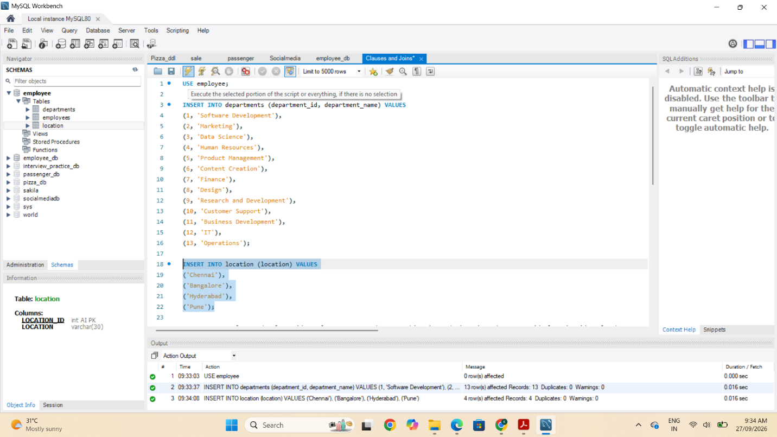
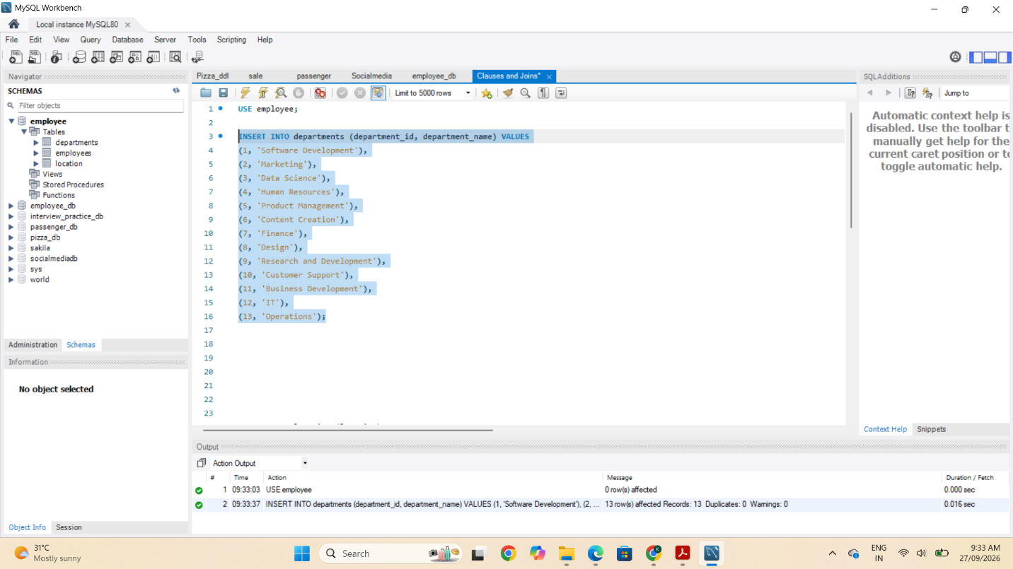
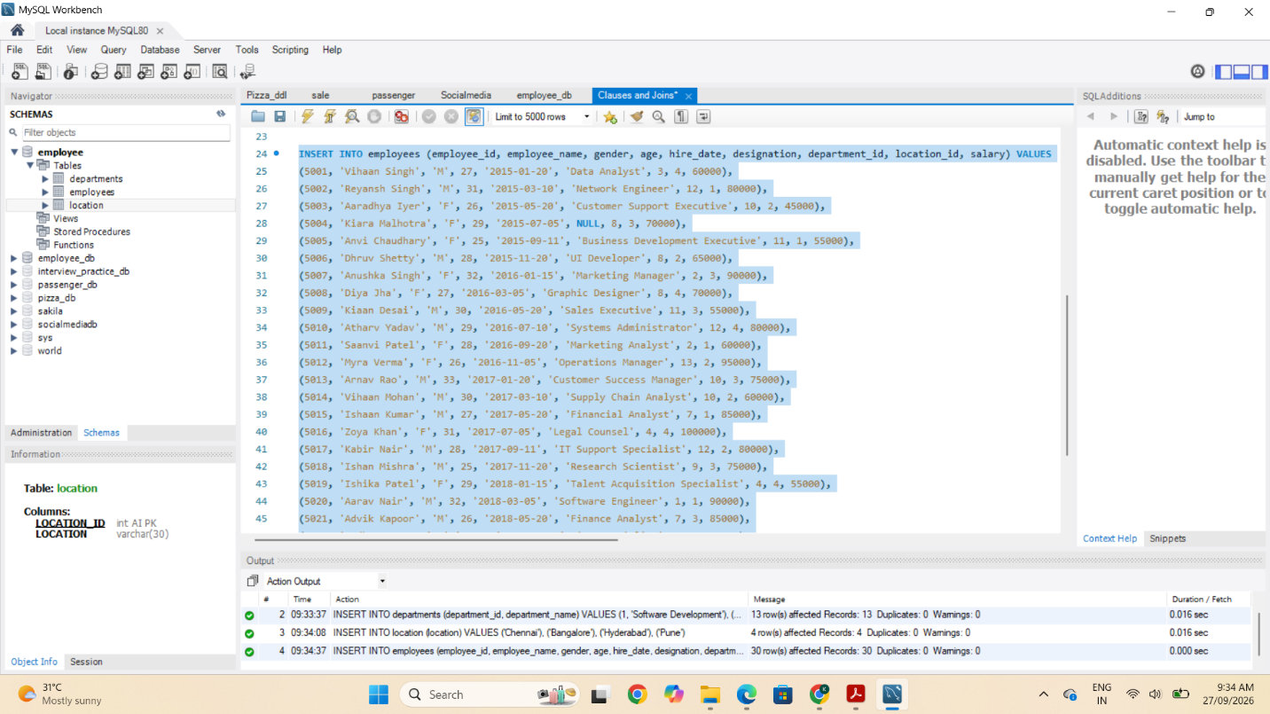
1. Distinct Values:
- a query to retrieve distinct salaries from the Employees table.
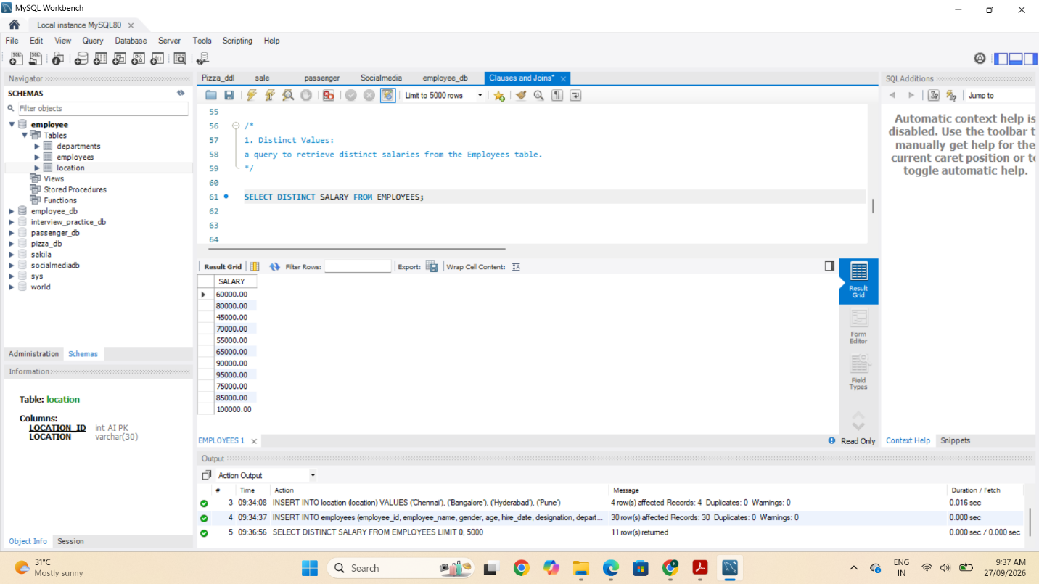

2. Alias (AS):
- Provide aliases for the "age" and "salary" columns as "Employee_Age" and "Employee_Salary", respectively.
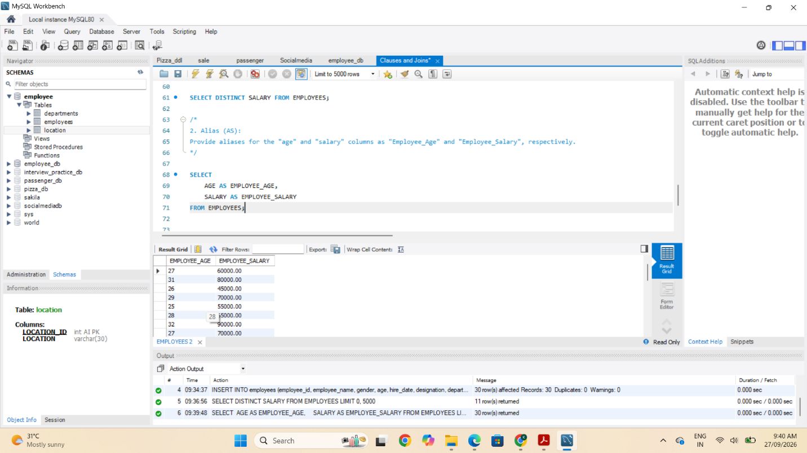
3. Where Clause & Operators:
- Retrieve employees with a salary greater than ₹50000 and hired before 2016-01-01.
- Find the employee whose designation is missing and fill it with "Data Scientist".

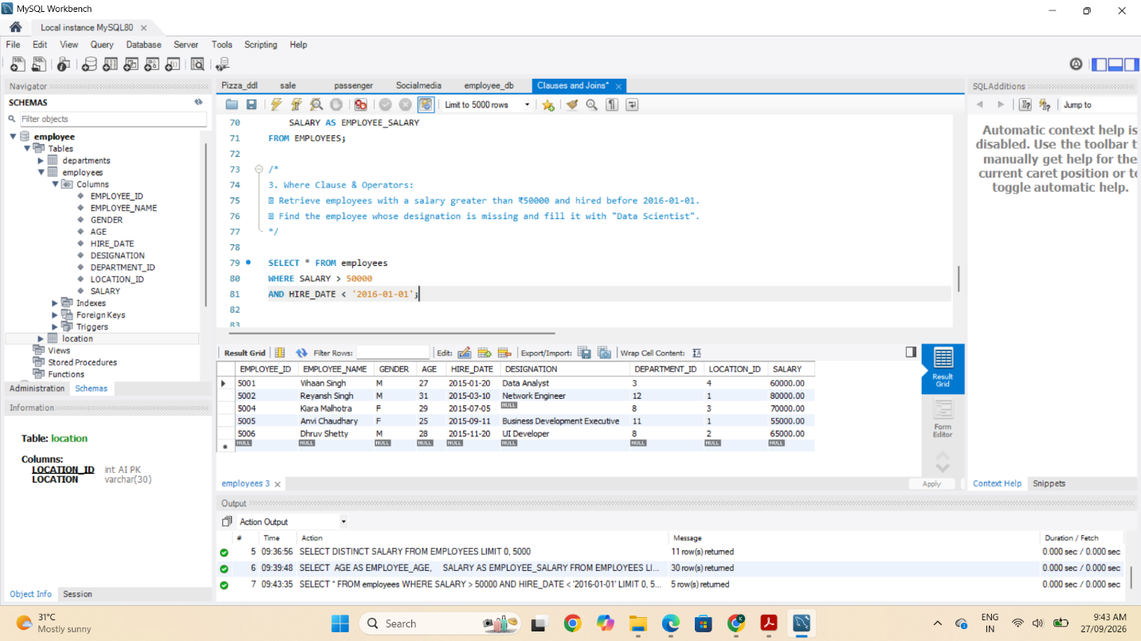

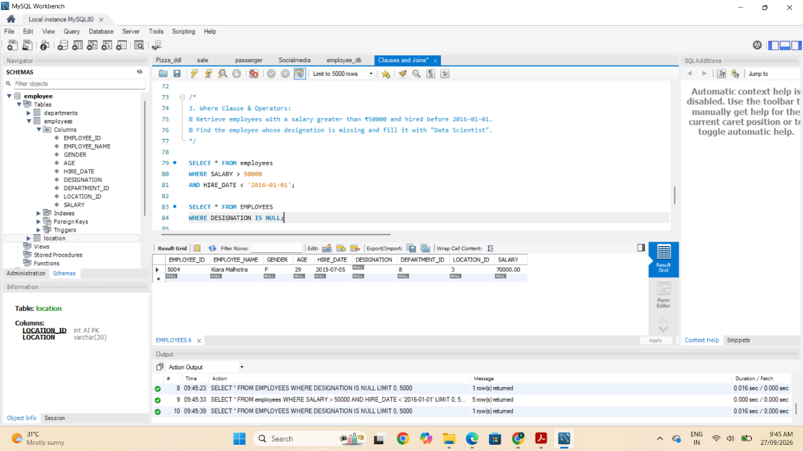

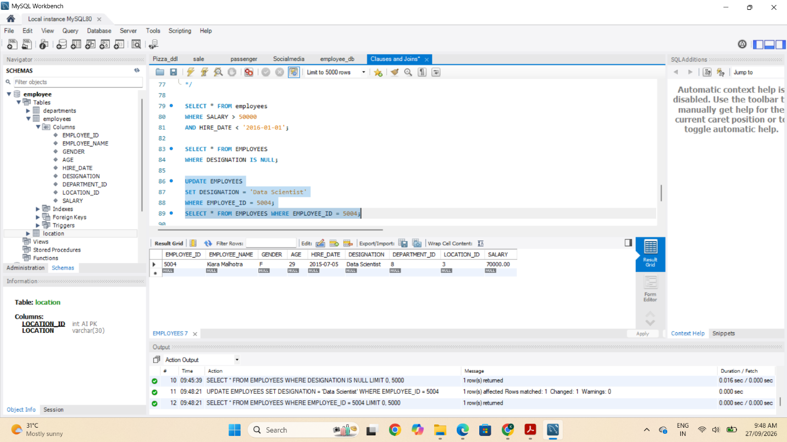
1. ORDER BY:
- Find employees sorted by department ID in ascending order and salary in descending order.
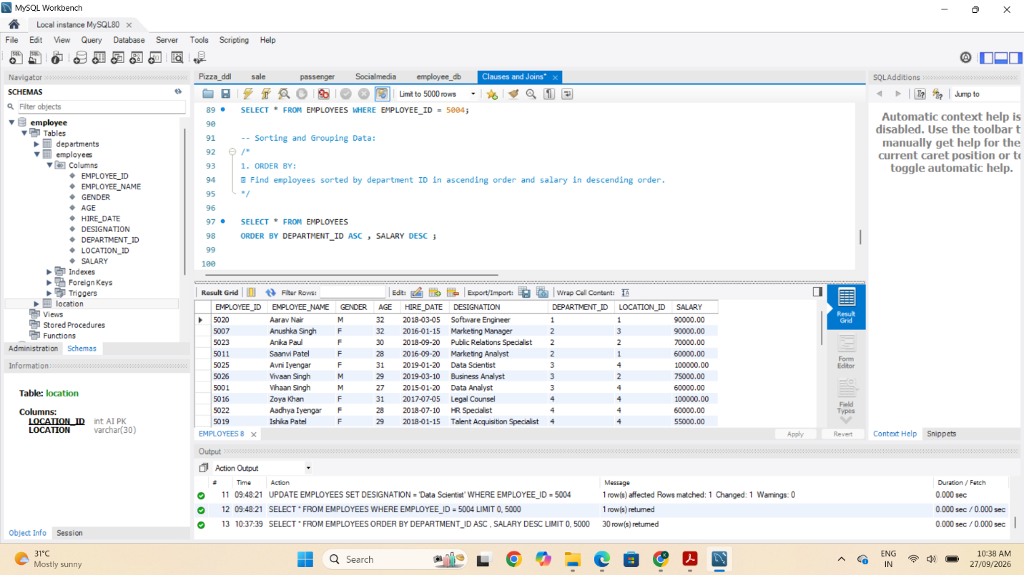

2. LIMIT:
- Display the first 5 employees hired in the year 2018.
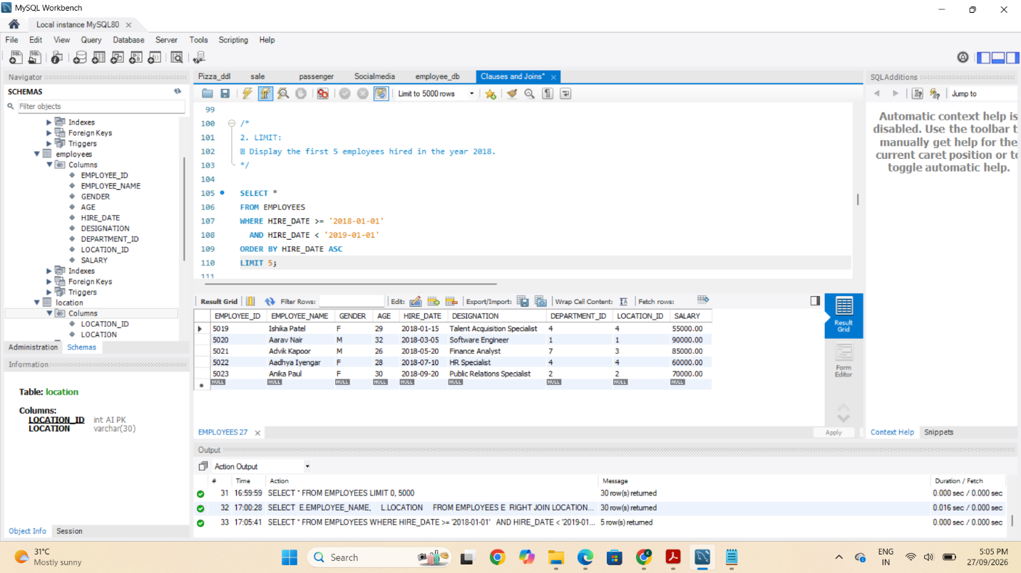
3. Aggregate Functions:
- Calculate the sum of all salaries in the Finance department.
- Find the minimum age among all employees.
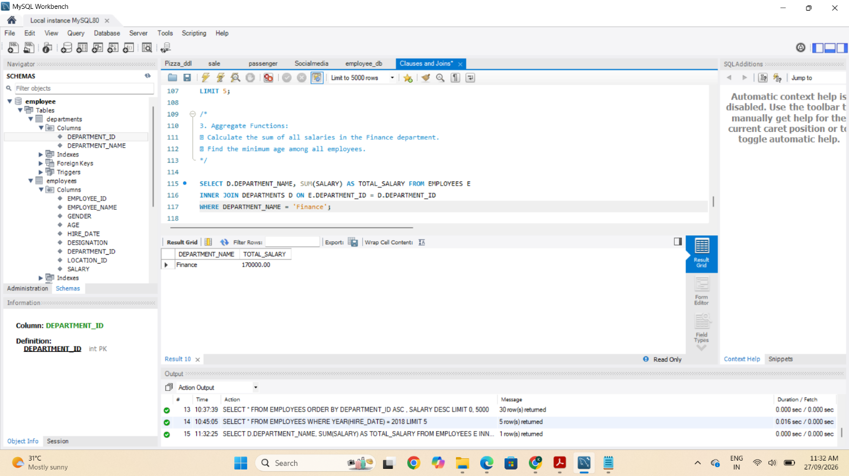

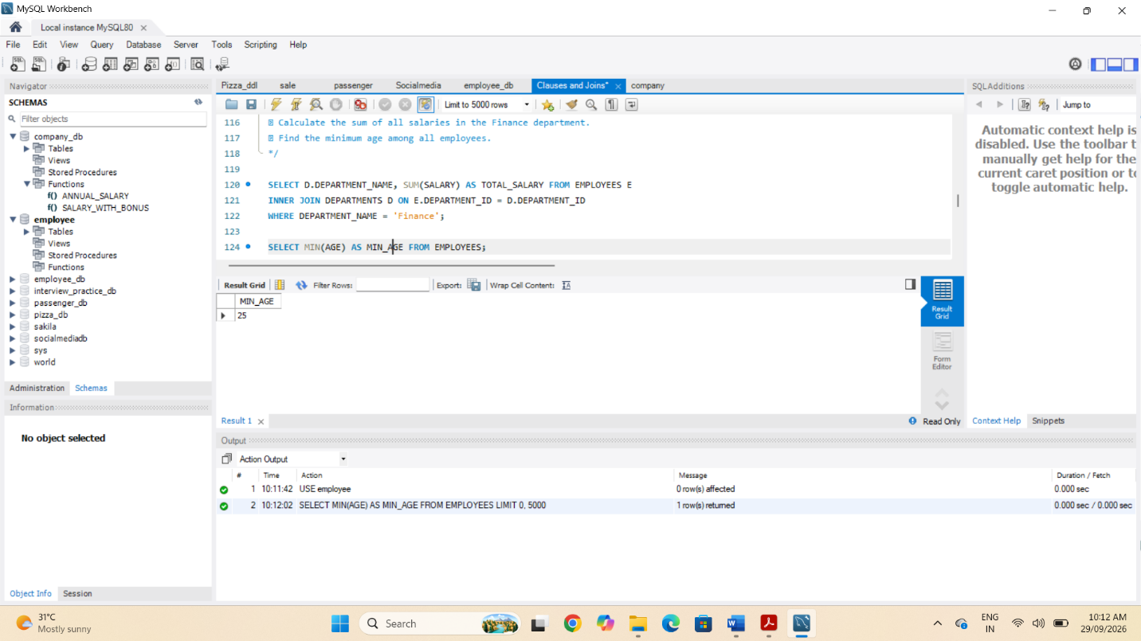

4. GROUP BY:
- List the maximum salary for each location.
- Calculate the average salary for each designation containing the word 'Analyst'.
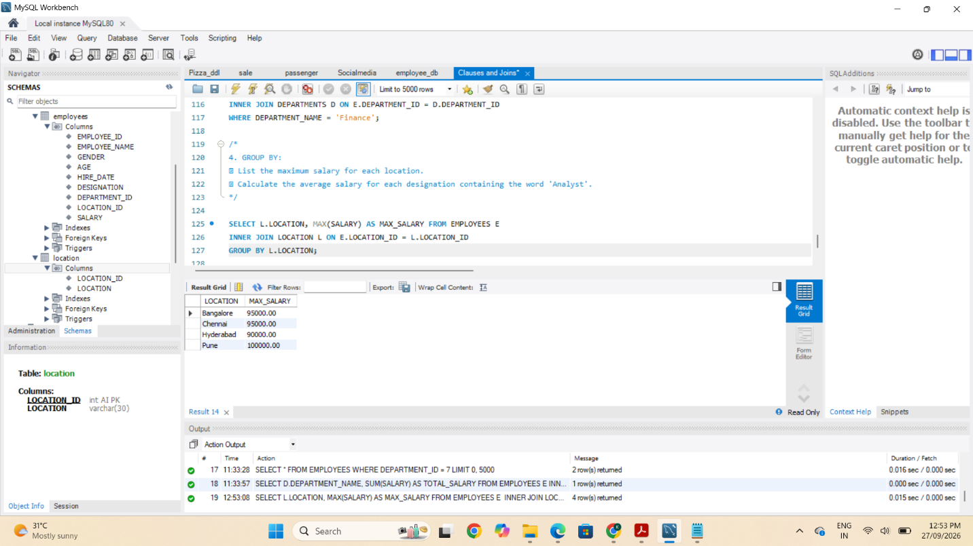
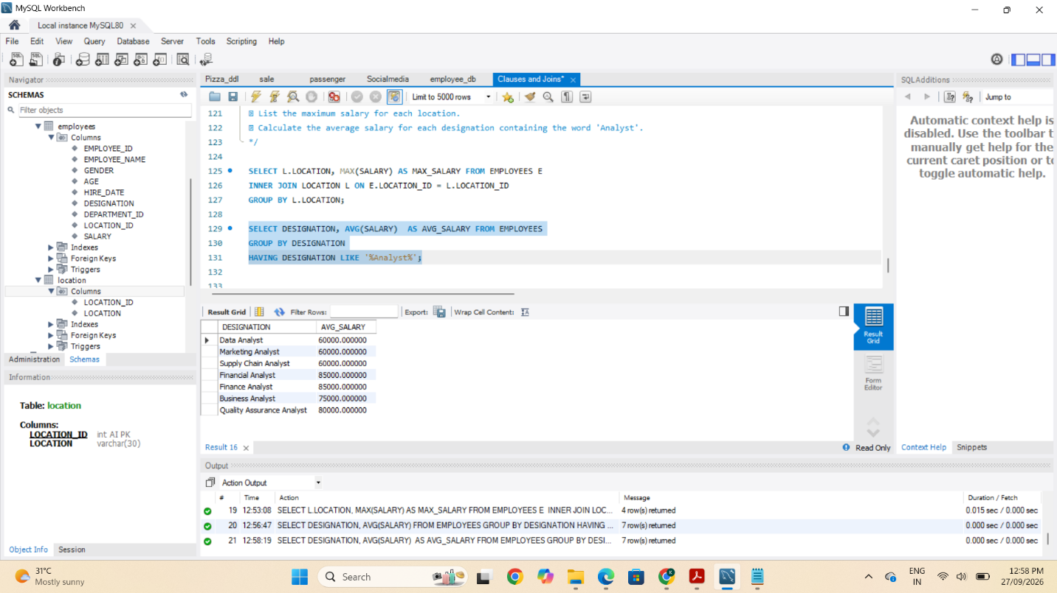

5. HAVING:
- Find departments with less than 3 employees.
- Find locations with female employees whose average age is below 30.

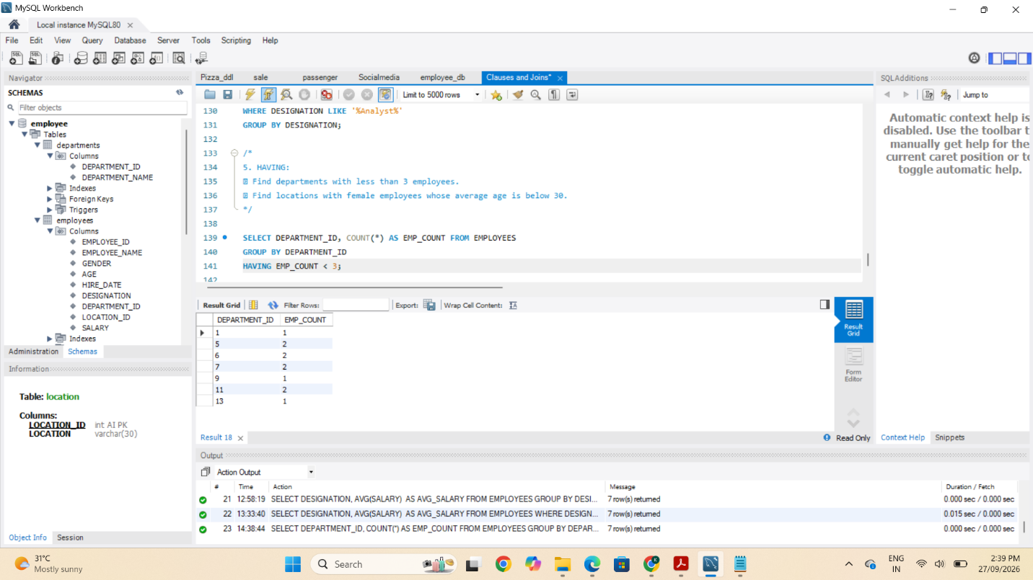
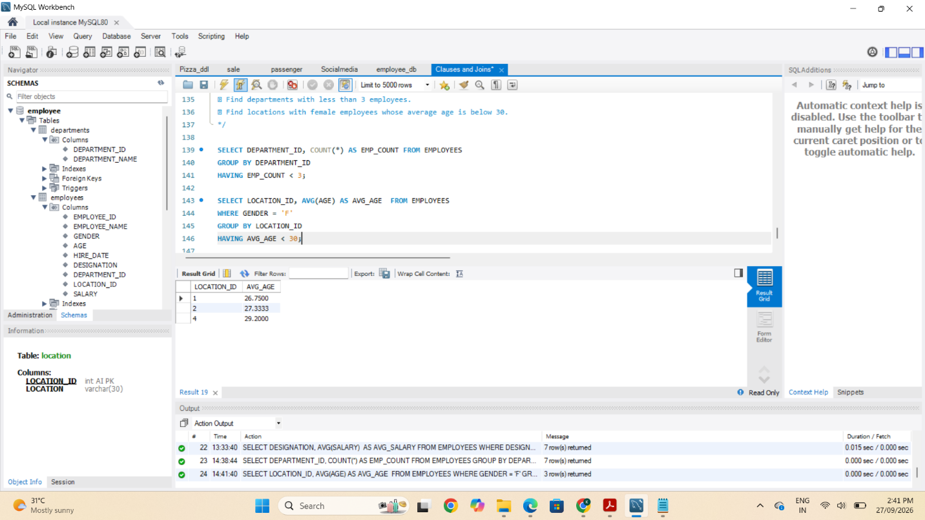
Joins:
1. Inner Join:
- List employee names, their designations, and department names where employees are assigned to a department.
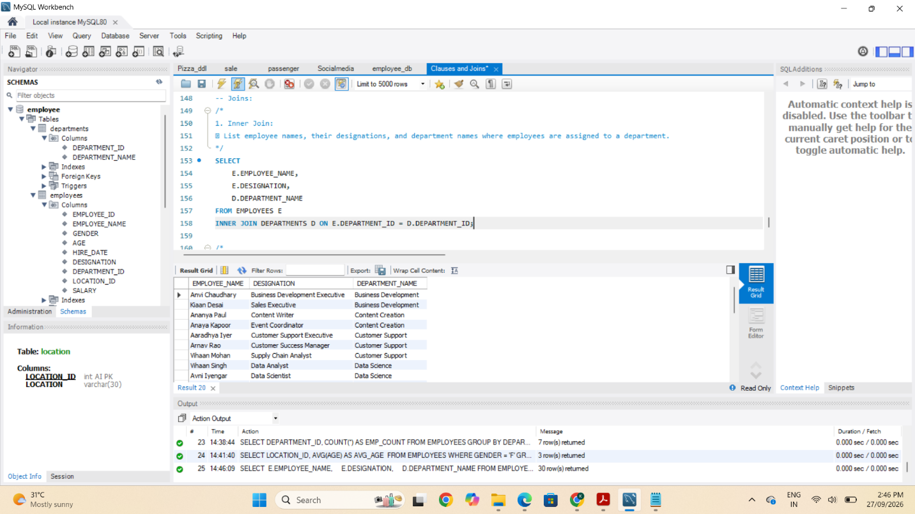
2. Left Join:
- List all departments along with the total number of employees in each department, including departments with no employees.

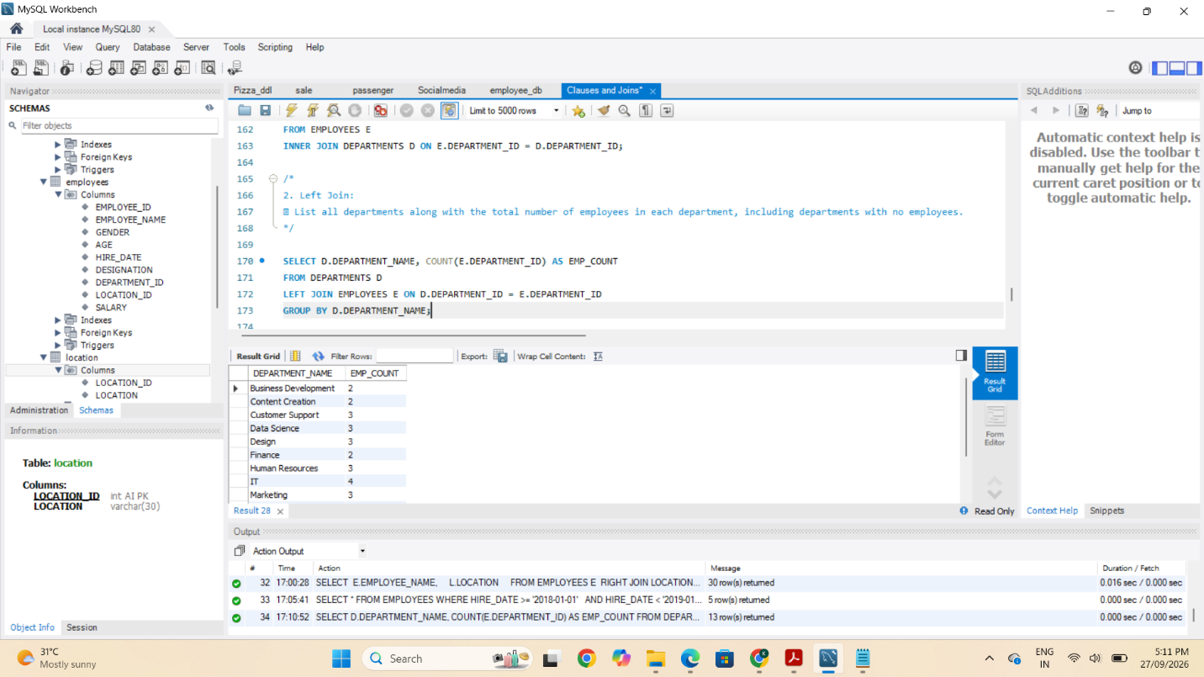
3. Right Join:
- Display all locations along with the names of employees assigned to each location. If no employees are assigned to a location, display NULL for employee name.
